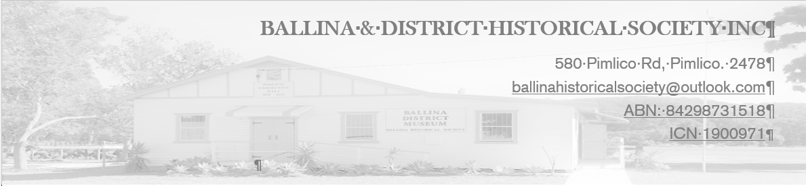

COLLECTION OFFER FORM
Thank you for your interest in donating to the Ballina and District Historical Society. It is very much appreciated. Please note that we do not accept loans unless we are undertaking a temporary exhibition. Items must be donated to the society. Please complete this form as best you can, sign and then either:
- email your completed form to ballinahistoricalsociety@outlook.com or
- contact Ann Mulder, Secretary, on 0427 291 772 and we can collect.
First name:
Surname:
Address: Number & Street:
Town/Suburb:
State: | Postcode:
Phone:
Email:
Ownership: Owner/acting on behalf of another (please circle)
What is it? Briefly describe the object or collection, including its main uses, significance and how and when it was acquired.

What is its size? Please list the approximate dimensions of an object, or the number of objects in a collection.

Who made it? Please give details of the creator or manufacturer.

Where and when was it made?

Where is it now?

What is its condition?

Photographs? Please send as an email attachment to ballinahistoricalsociety@outlook.com
More. Please provide any extra information you think may be relevant
I acknowledge that this donation is a gift to the Ballina & District Historical Society and not a loan (please tick the box if you agree and sign below)
Signature:

