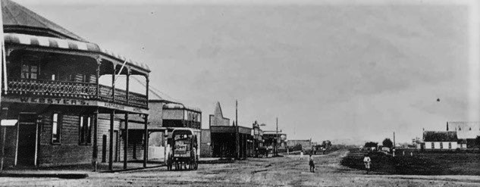
BALLINA & DISTRICT HISTORICAL SOCIETY
President: Allan Hicks 0416 251 829
Exec Secretary: Ann Mulder 0427 291 772
ballinahistoricalsociety@outlook.com
ICN 1900971

APPLICATION FOR MEMBERSHIP FORM
 | First name:
 | Surname:
 | Number & Street:
 | Town/Suburb:
 | State: |  | Postcode:
 | Phone: |  | Date of Birth:
 | Email:
Membership of the Ballina & District Historical Society costs:
- One-off joining fee of $10 per person plus
- an annual fee at $20 for one person or $30 for a couple
Membership is for the 2019/2020 financial year with a common renewal date of July 1 each year.
You can make your payment electronically using the account details below, pay at our monthly meetings or go to any St George Bank branch to deposit the fee.
Account details:
Ballina and District Historical Society
BSB: 112879
Account number: 478716649
Reference: Your Name
Privacy/Sharing: I/we, the undersigned understand that my/our membership details will be kept confidential and will only be accessed by the executive committee for the purpose of contacting you regarding membership fees or other important information as determined by the executive committee.

Signature: ___________________________________________Date: _____________________________________

Signature: ___________________________________________Date: _____________________________________

